SIMATS ENGINEERING (SAVEETHA SCHOOL OF ENGINEERING)
Department of Computer Science and Engineering
CO2 ASSESSMENT TOOL 1 – Scenario-Based Requirement Analysis

Course Code: | CSA10 / CSA1063 | Course Title: | Software Engineering
CO Assessed: | CO2 | Assessment: | Assessment Tool 2 – Scenario-Based Requirement Analysis
Weightage: | 20% | Total Marks: | 25
CO2 Statement: | Perform detailed requirements analysis, design scalable architectures, and prioritize features with a focus on cross-disciplinary skills
Student Name: |  | Reg. No.:
Date: |  | Duration: | 60 minutes

Code of Conduct
I G. Akshya (192425132) (Name / Reg No) certify that this submission is my original work and that I have adhered to the guidelines specified for this assessment. I understand that any violation of academic integrity rules will result in disciplinary action.
Signature of the Student: 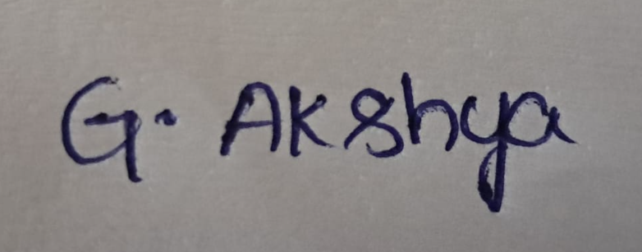
Annexure A – Scenario-Based Requirement Analysis
Instructions to Students:
Each student will be assigned an individual software project problem statement. Analyze the given scenario and prepare a complete Software Requirement Analysis document by following the steps below.

Question
Based on the assigned problem statement, perform a Scenario-Based Requirement Analysis and prepare a Software Requirement Specification (SRS) document. Your analysis should include the following:
- Study and Analyse the Scenario
  - Carefully understand the given problem statement.
  - Identify the business domain, stakeholders, existing challenges, and system objectives.
- Identify Functional and Non-Functional Requirements
  - List all functional requirements required by the proposed system.
  - Identify suitable non-functional requirements such as performance, security, reliability, usability, scalability, maintainability, and availability.
- Identify Actors and Use Cases
  - Identify all primary and secondary actors interacting with the system.
  - List the major use cases associated with each actor.
  - Draw a Use Case Diagram representing the interactions between actors and the system.
- Prepare the Software Requirement Specification (SRS)
Develop an SRS document containing:
  - Introduction
  - Problem Description
  - Scope of the System
  - Functional Requirements
  - Non-Functional Requirements
  - Use Case Descriptions
  - Data Requirements
  - External Interface Requirements
  - System Features
- Identify Assumptions and Constraints
  - List the assumptions considered while developing the system.
  - Identify technical, operational, economic, legal, and time-related constraints affecting the project.
- Validate Requirement Completeness and Consistency
  - Verify whether all stakeholder requirements have been addressed.
  - Check for ambiguity, redundancy, inconsistency, and missing requirements.
  - Suggest improvements to enhance the quality and completeness of the requirement specification.
Rubrics for Calculation
Criteria | Excellent (4 Marks) | Good (3 Marks) | Satisfactory (2 Marks) | Needs Improvement (1 Mark)
Scenario Understanding and Problem Analysis | Demonstrates thorough understanding of the scenario, stakeholders, objectives, and business context with clear analysis. | Demonstrates good understanding with minor omissions. | Basic understanding with limited analysis. | Poor understanding; major aspects missing or incorrect.
Functional and Non-Functional Requirement Identification | Clearly identifies comprehensive, accurate, and well-classified functional and non-functional requirements. | Identifies most requirements with minor classification errors. | Identifies only basic requirements; several omissions. | Requirements are incomplete, inaccurate, or poorly classified.
Actor Identification and Use Case Modelling | Correctly identifies all relevant actors and use cases; use case diagram is complete, accurate, and follows UML standards. | Most actors and use cases identified; diagram has minor errors. | Limited actors/use cases identified; diagram partially correct. | Actors/use cases missing or incorrect; diagram absent or inaccurate.
Software Requirement Specification (SRS) Documentation | SRS is well-structured, complete, professionally organized, and includes all required sections. | SRS is organized with minor missing sections or formatting issues. | SRS includes only essential sections with limited detail. | SRS is incomplete, poorly organized, or lacks essential components.
Assumptions, Constraints, and Requirement Validation | Clearly identifies realistic assumptions and constraints; validates requirements for completeness, consistency, and ambiguity with appropriate justification. | Identifies most assumptions and constraints; validation is adequate. | Limited assumptions/constraints; validation is superficial. | Assumptions, constraints, and validation are missing or incorrect.

Criteria | Mark
Scenario Understanding and Problem Analysis | /5
Functional and Non-Functional Requirement Identification | /5
Actor Identification and Use Case Modelling | /5
Software Requirement Specification (SRS) Documentation | /5
Assumptions, Constraints, and Requirement Validation | /5
TOTAL | /5

CO2-Assessment Tool-1
Software Requirement Specification
Project: Smart Vertical Farming Automation Platform
Name: -G. Akshya Course Code: CSA1007
Reg No: -192425132 Slot-D

1. Introduction
- The Smart Vertical Farming Automation Platform is an intelligent software solution designed to automate and monitor vertical farming operations.
- The system integrates sensors, automation devices and data analytics to improve crop production while reducing manual effort.

2. Problem Description
- Traditional farming relies heavily on manual monitoring, resulting in water wastage, inconsistent crop growth and delayed decision making. Vertical farming introduces controlled environments, but managing them manually becomes difficult as the farm expands.
- The proposed system automates these activities using smart sensors, scheduling and analytics to improve efficiency and sustainability.

3. Objectives
- Monitor environmental conditions continuously.
- Optimize irrigation automatically based on sensor values.
- Predict crop health using historical and real-time data.
- Automate lighting schedules.
- Generate production and performance reports.
- Notify farm operators about abnormal conditions.

4. Scope of the System
The system supports sensor monitoring, irrigation automation, lighting control, crop health monitoring, report generation, user management and notification services. Future versions may include drone monitoring and AI yield forecasting.

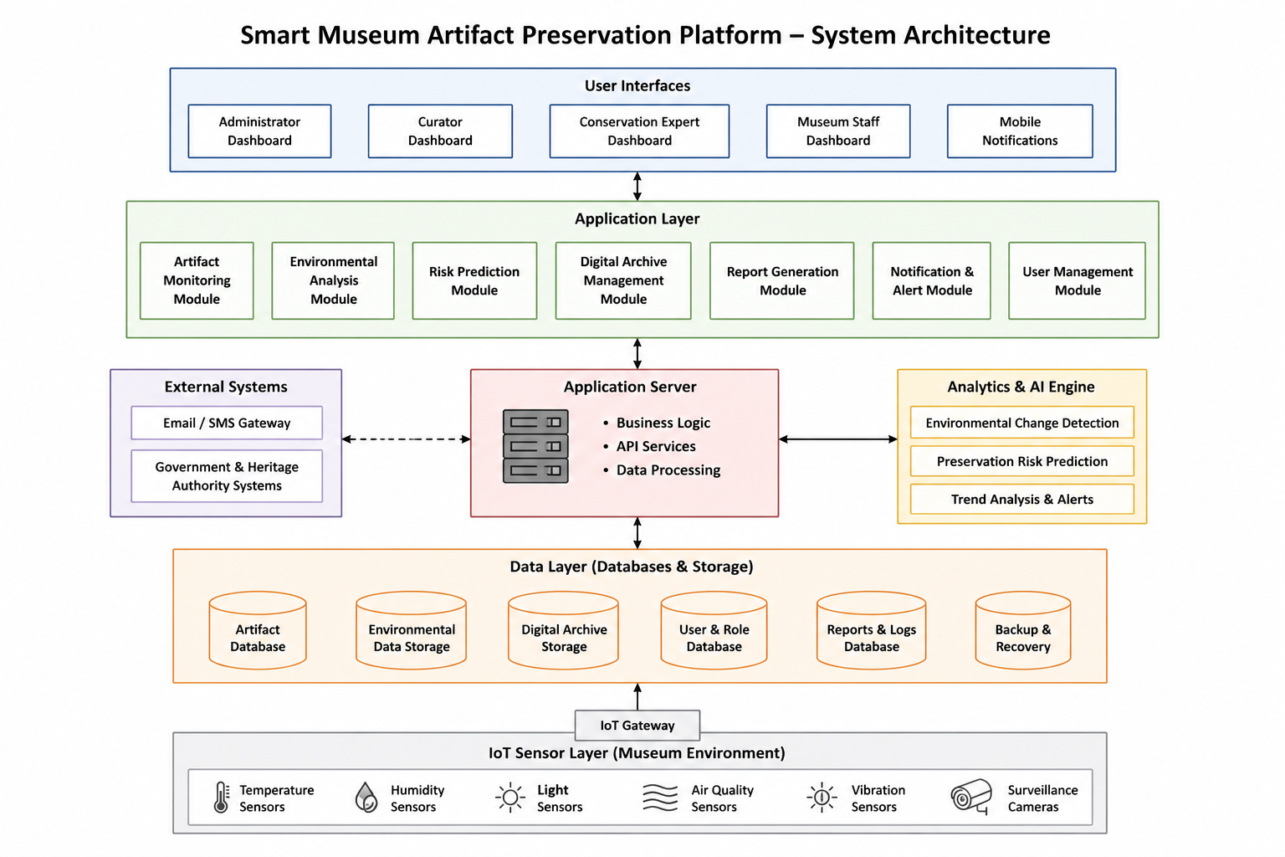

5. Stakeholders
- Farm Owner – monitors production and business performance.
- Farm Operator – manages daily farming activities.
- Administrator – manages users, sensors and configurations.
- Maintenance Engineer – maintains IoT devices.
- Customers/Management – reviews production reports.

7. Non-Functional Requirements
- Performance: Dashboard updates within a few seconds.
- Security: Role-based authentication and encrypted communication.
- Reliability: Continuous operation with minimal downtime.
- Scalability: Supports additional sensors and farms.
- Backup and Recovery: Automatic database backup.
- Data Integrity: Accurate storage of sensor readings.

8. Actors and Major Use Cases
Actors: Administrator, Farm Operator, Sensor System, Notification Service.
Use Cases: Login, View Dashboard, Monitor Sensors, Start Irrigation, Stop Irrigation, Configure Lighting, Predict Crop Health, Generate Reports, Receive Alerts, Manage Users.

9. Data Requirements
The database stores user profiles, sensor readings, irrigation schedules, lighting schedules, crop information, alerts, production reports and audit logs.

10. External Interface Requirements
Hardware Interface: IoT sensors, pumps and lighting controllers.
Software Interface: Database server, analytics engine and notification service.
User Interface: Responsive web dashboard.

11. System Features
- Real-time monitoring dashboard.
- Lighting automation.
- Crop health prediction.
- Alert management.
- Historical trend analysis.
- Report generation.
- User and device management.

12. Conclusion
The proposed Smart Vertical Farming Automation Platform provides an efficient, scalable and sustainable solution for modern agriculture by integrating monitoring, automation and reporting into a single platform.
Code of Content
I G. Akshya (192425132) certify that this submission is my
original work and that I have adhered to the guidelines specified for this assessment.
I understand that any violation of academic integrity rules will result in disciplinary
action.

Signature of the student: G. Akshya

